NAME: UMUTONI Nicole
ID: 24925

PL/SQL Assignment

STEP 1: PROBLEM DEFINITION
- Business context
A tech company selling electronics (smartphones, laptops, accessories) within regions of the country.

- Data challenge
The company stores data on customers, products and sales separately but lacks clear visibility on the following issues makes it difficult to make data driven decisions:
- Which product performs best in each region
- Sale growth trends trends periodically
- High value customer segment for targeted promotion

- Expected outcomes
Provide analytical insights that help:
- Identify top performing product
- Track sales trends over time
- Customer quartile segmentation

STEP 2: SUCCESS CRITERIA
- Identify top 5 products per region using RANK ()
- Calculate running monthly sales totals using SUM ()
- Analyze monthly sales growth using LAG ()
- Segment customers into quartiles based on total spending using NTILE (4)
- Compute a 3-month moving average of sales using AVG () OVER ()

STEP 3: DATABASE SCHEMA DESIGN
TABLES:
- Customer:
    - customer_id (pk)
    - Customer_name
    - Region
    - email
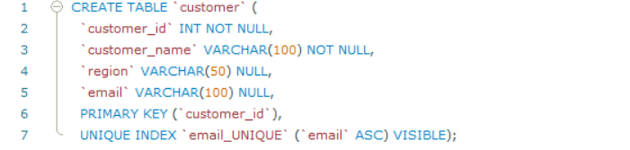

- products:
- product_id (pk)
- product_name
- category
- unit_price
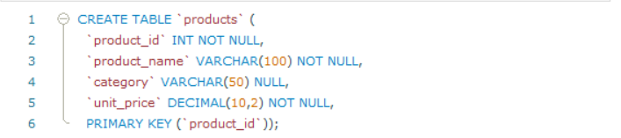
- sales:
- sale_id(pK)
- customer_id
- product_id
- sale_date
- quantity
- amount
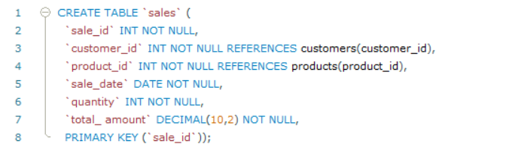

ER DIAGRAM
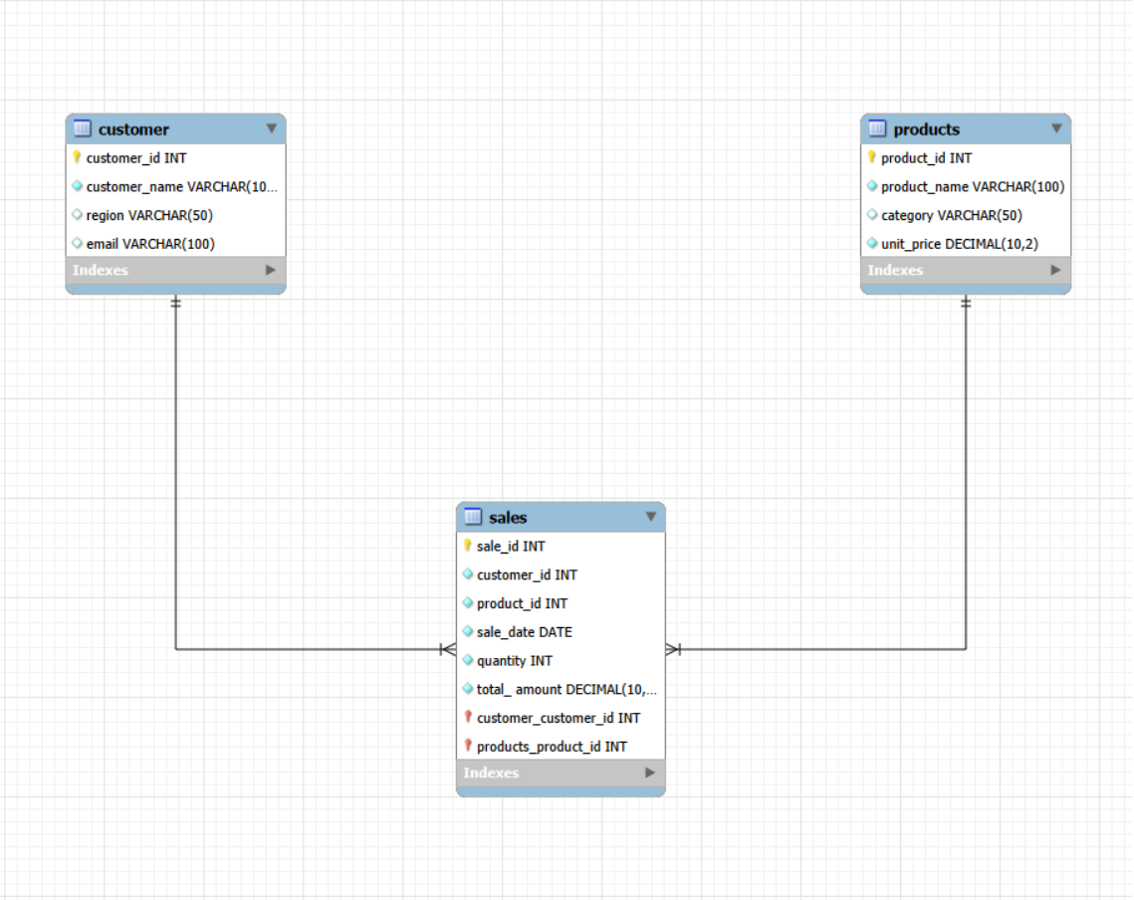

Step 4: SQL JOINS implementation
- INNER JOIN
Retrieve transactions with valid customers and products.
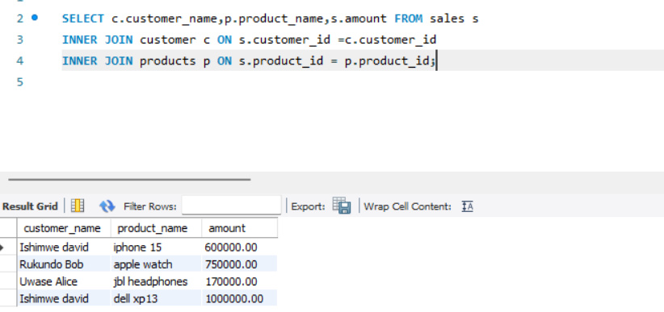

Interpretation: Shows only valid sales records where both customer and product exist.

- LEFT JOIN
Identify customers who have never made a transaction.
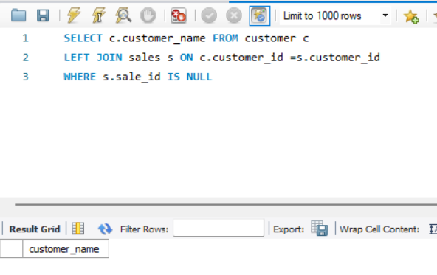
Interpretation: Helps identify inactive customers for re-engagement campaigns.
- RIGHT JOIN
Detect products with no sales activity.
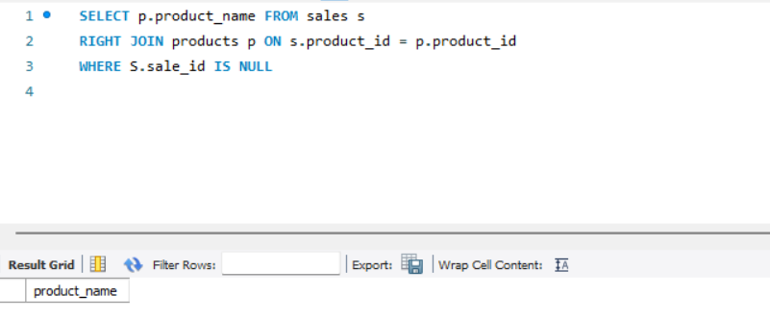

Business Interpretation: Identifies products that may need promotion or discontinuation.

- SELF JOIN
Compare customers within the same region.
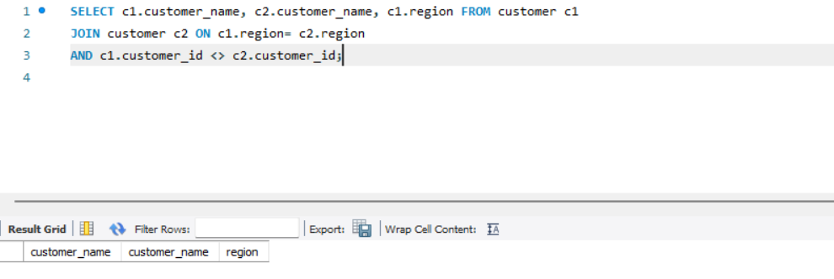
Business Interpretation: Allows comparison of customers operating in the same market region.

STEP 5: Window Functions
- Ranking Functions
Top products by revenue
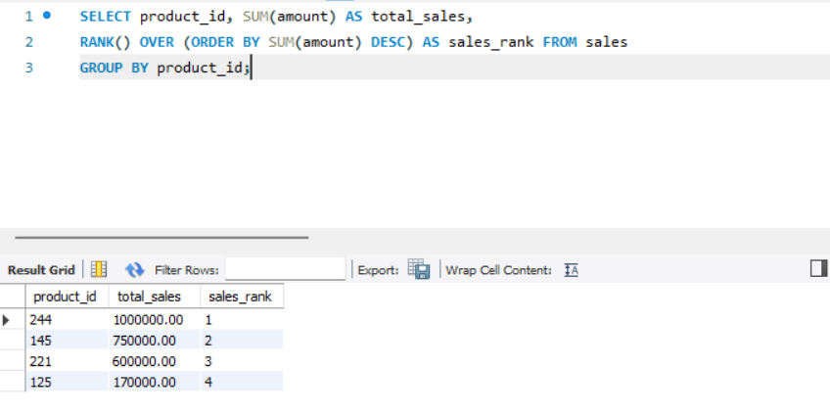
Interpretation:Ranks products based on total revenue generated.
- Aggregate Window Functions

Running monthly sales total
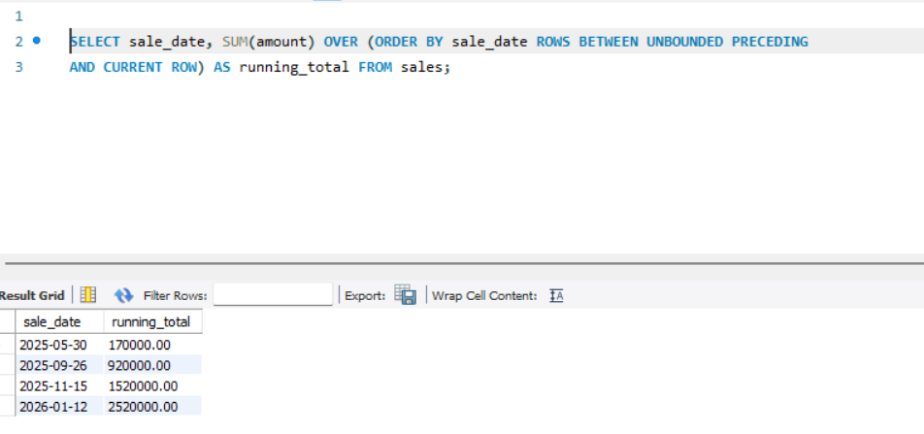

Interpretation: Shows cumulative sales growth over time.
3. Navigation Functions
Monthly comparison
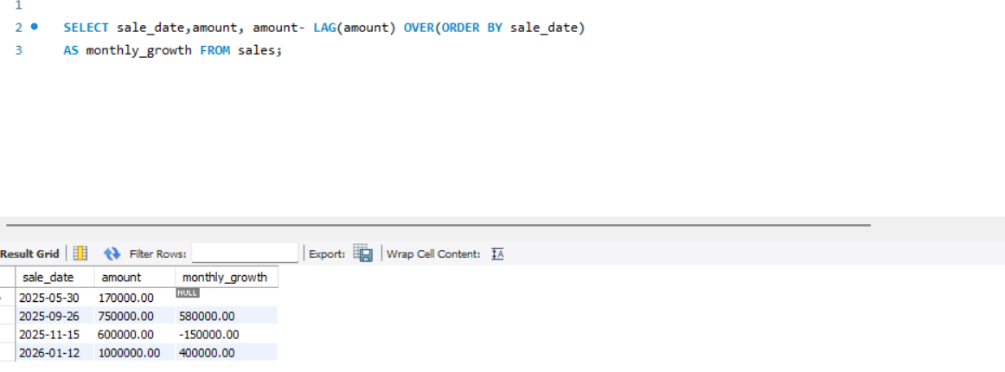

Interpretation:Highlights increases or decreases in sales between periods.
4.Distribution Functions
Customer quartile segmentation
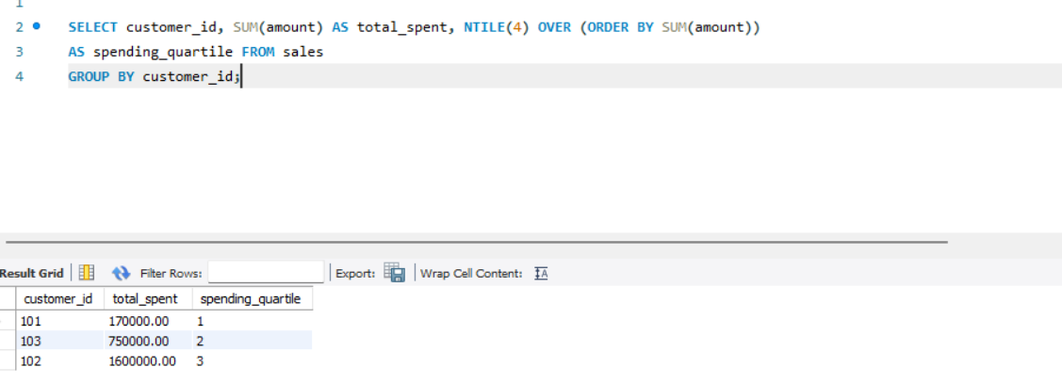

Interpretation: Segments customers into four spending groups for targeted strategies.

STEP 6: RESULT ANALYSIS
Descriptive
Sales are concentrated in a small number of products and high-value customers.
Diagnostic
Revenue differences are driven by customer spending patterns and regional demand.
Prescriptive
Focus marketing on top quartile customers and promote underperforming products.
STEP 7: References
Oracle SQL Documentation
PostgreSQL Window Functions Guide
SQL Tutorial (W3Schools)

